1. Design Forms licensing system
   1. License types

Design Forms provide two kind of licenses:

* **Local license** - license is stored in file, save on local harddisk.

Path to the licence file: c:\ProgramData\DesignForms_0.1\DesignForms.lic

License file contains encrypted data about license type, license content, local computer, IP address and others.

Local license is bound to specific computer, can't be transferred without uninstalling.

* **Network license** - network license is provided by license server through local area network.

Network license is floating - it is issued by the server when client is connected. No data are saved on local client machine.

Client must be connected to Server all the time.

1. Installing client license
   1. Introduction

User is automatically prompted to install license when no license is defined. This typically happens when the application is start for the first time.

When no license is detected, you will see following dialog:

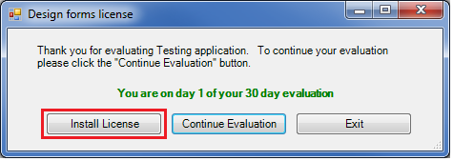

**Dialog options:**

* Install license - open Install license dialog, which is used to define local or network license.
* Continue evaluation - program is started with demo (evaluation) license. User is allowed to evaluate application for 30 + 5 days.
* Exit - terminates the application
  1. Installing local license

1. Select "Local license" option.

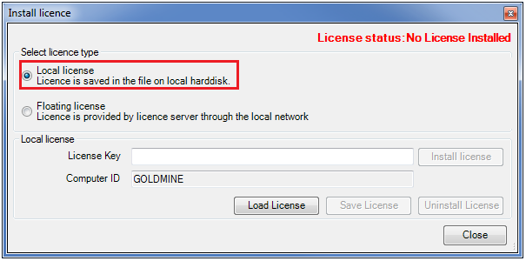

1. Copy (Ctrl + C) your license key which you received with your purchase and paste it (Ctrl + V) into input field "License Key".

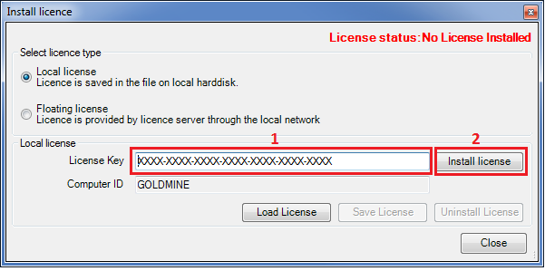

1. Clicking "Install license" run the authentication procedure.
2. When the license is successfully verified, you will see green confirmation message in upper right corner:

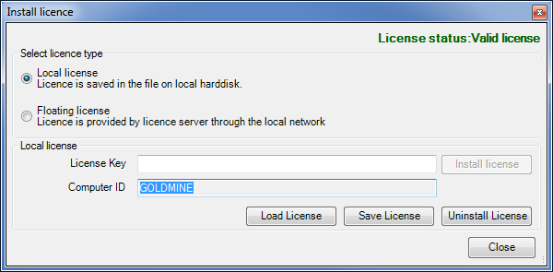

1. Close the installation dialog clicking "Close" button.
2. Your license is installed, you can start using Design Forms.
   1. Installing network license
3. Select "Floating license" option.

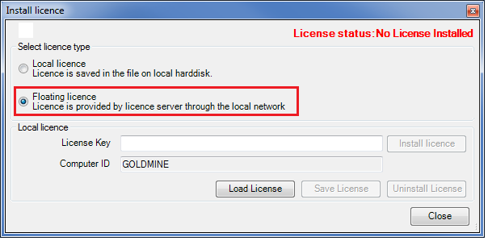

1. Make sure, you are connected to local network.
2. If you / your company are using Virtual Private Network (VPN), make sure, you are connected.
3. Type name of license server to "Server Address" field.

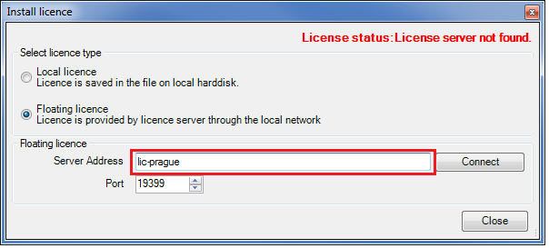

1. Click "Connect" to get network license from the server

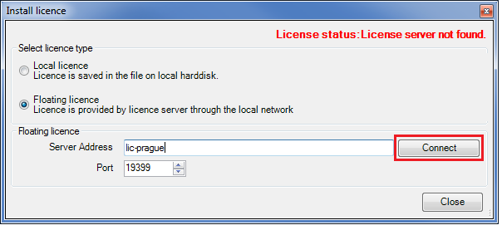

1. When network license is obtained successfully, you will see green confirmation message in the top right corner.

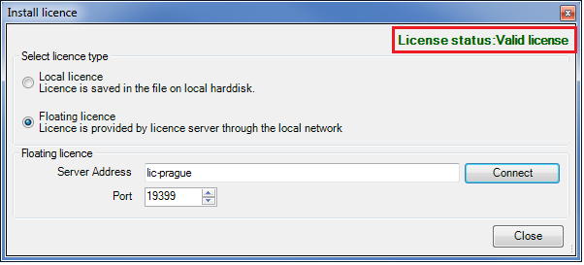

1. Close the installation dialog clicking "Close" button.
2. Your license is installed, you can start using Design Forms.
3. Installing licence server

License server provides network licenses for clients connected through local network.

License server is Microsoft Windows Service.

You need administrator rights to be able install and setup license server.

License server is installed and managed using command line parameters.

Complete list of command line parameters:

* /I - install license server
* /U - uninstall license server
* /L - open dialog for loading server license
  1. Install DesignForms Licence server

1. Run "DesignForms_LicenceServer.exe" with command line parameter "/I"
2. This will create new Windows Service "DesignForms_LicenseServer".
3. This service is started automatically after Windows boot.
4. Make sure, service is properly installed and running.

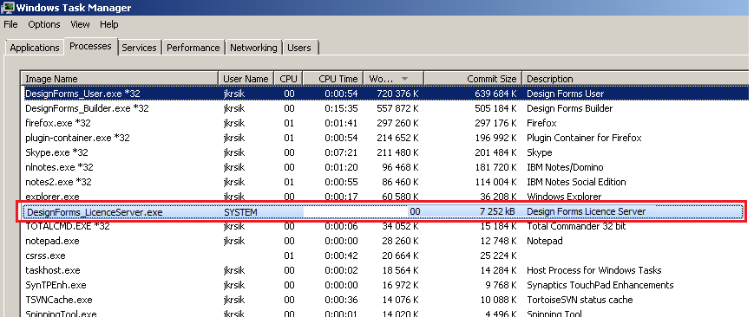

Process "DesignForms_LicenseServer" is running.

Turn ON "Show processes of all users" option!

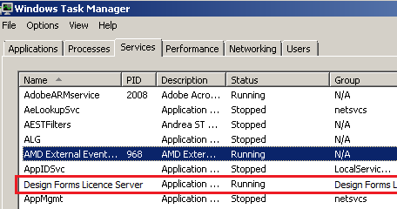

"Design Forms Licence Server" in Windows services.

* 1. Install licence key to the Licence server

1. Run "DesignForms_LicenceServer.exe" with command line parameter "/L"
2. Follow instructions for local license installation.
3. Your licence server is installed successfully, clients are able to connect.
   1. Trouble-shooting:

**Server installation failed:**

DesignForms_LicenceServer.exe must be running with administrator rights.

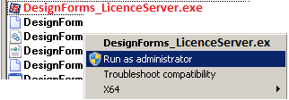

**Clients are not able to connect to Server:**

Check settings of Windows Firewall.

Add exception / permission to "DesignForms_LicenceServer.exe" - incoming and outgoing communication.

**One client is not able to connect to Server:**

Make sure client is connected to VPN (if VPN is used within your company) .

Check firewall settings.